

**St. Stephen’s Primary School**

**Behaviour Policy**

|  |  |
| --- | --- |
| **DATE APPROVED BY ST. STEPHEN’S CE**  **PRIMARY SCHOOL** | **Autumn Term 2024** |
| **REVIEW DATE** | **Autumn Term 2025** |
| **APPROVED BY** | **Full Governing Body** |

At St Stephen’s CE Primary School, our mission statement is at the heart of everything we do.

*Encourage each other and build each other up, just as you are already doing. (1 Thessalonians 5:11).*

Our spiritual values of friendship, thankfulness, kindness, forgiveness, respect (for the environment), service and respect are a core part of our behaviour policy. We take a positive whole-school approach to behaviour management in which all members of staff cooperate and support each other in the development of appropriate behaviour in school. This policy supports the fostering of self-confidence, self-respect and self-discipline and to be able to work with others in a spirit of cooperation.

The physical, social and emotional environment in which staff and students spend a high proportion of every week day has been shown to affect their physical, emotional and mental health and wellbeing as well as impaction on attainment. Relationships between staff and students, and between students, are critical in promoting student wellbeing and in helping to engender a sense of liking of school.

The points covered in this policy reflect the UNCRC and our commitment to it – we understand the Articles affecting children’s’ rights in respect of behaviour are:

• Article 2 – We treat every child equally - without discrimination

• Article 3 – Every child is treated equally; everything we do is in their best interests

• Article 4 – We respect and protect the rights of every child

• Article 5 – We respect the rights and responsibilities of parents to guide and advise their child and work together with them to ensure they apply their rights properly

• Article 6 – We ensure that every child survive and develop to grow up to be healthy and happy wherever possible

• Article 8 – We preserve the identity of every child

• Article 13 – We ensure that every child has the right to say what they think and how they feel

• Article 15 – We ensure that every child has the right to meet with other young people and join groups and organisations as long as it does not impact on anyone else enjoying their rights

• Article 19 – We do everything we can to ensure that every child is protected from all forms of violence, abuse, and mistreatment

• Article 18 – We respect and encourage parents to share responsibility for bringing up their child, always considering what is best for them

• Article 31 – We respect and ensure that every child has the right to relax, play and join in a wide range of cultural and artistic activities​

At St Stephen’s we are an **Attachment Aware School.**

Through being attachment aware, both children and adults are able to both manage their behaviour and to create an environment that is conducive to learning, building positive relationships between children, staff and children with their peers. Staff are trained in attachment awareness. (See appendix 3)

1. **Aims**

This Policy aims to:

* Provide a **consistent approach** to behaviour management within a caring, friendly, safe and relaxed environment.
* To foster Christian values of consideration and respect for others, cooperation and tolerance, sharing and compassion and to maintain these values throughout all school activities.
* **Define** what we consider to be unacceptable behaviour, including bullying
* Outline **how pupils are expected to behave**
* Summarise the **roles and responsibilities** of different people in the school community with regards to behaviour management
* Outline our system of **rewards and sanctions**
* To ensure parents and the wider community have a clear understanding of the system to enable continuity and accurate communication
* Enable parents, staff and pupils to work in partnership to support school policies and expectations

# 2. Legislation and statutory requirements

This policy is based on advice from the Department for Education (DfE) on:

* [Behaviour and discipline in schools](https://www.gov.uk/government/publications/behaviour-and-discipline-in-schools)
* [The Equality Act 2010](https://www.gov.uk/government/publications/equality-act-2010-advice-for-schools)

It is also based on the [special educational needs and disability (SEND) code of practice](https://www.gov.uk/government/publications/send-code-of-practice-0-to-25).

In addition, this policy is based on:

* Section 175 of the [Education Act 2002](http://www.legislation.gov.uk/ukpga/2002/32/section/175), which outlines a school’s duty to safeguard and promote the welfare of its pupils
* Sections 88-94 of the [Education and Inspections Act 2006](http://www.legislation.gov.uk/ukpga/2006/40/section/88), which require schools to regulate pupils’ behaviour and publish a behaviour policy and written statement of behaviour principles, and give schools the authority to confiscate pupils’ property
* [DfE guidance](https://www.gov.uk/guidance/what-maintained-schools-must-publish-online#behaviour-policy) explaining that maintained schools should publish their behaviour policy online
* [Behaviour in schools: advice for headteachers and school staff 2022](https://www.gov.uk/government/publications/behaviour-in-schools--2)

**Behaviour Management**

St Stephen’s behaviour management is rooted in positivity.

“The most effective schools seem to be those that have created a positive atmosphere based on a sense of community and shared values”. (Discipline in Schools, chaired by Lord Elton, 1989)

Principles that support Positive behaviour:

* A calm, safe, predictable environment
* Wellbeing is promoted implicitly through lived values and attitudes
* Wellbeing is promoted explicitly through curriculum
* All staff understand behaviour as communication
* Clear expectations of behaviour for all stakeholders
* Enough flex in the behaviour policy to allow for behaviours that might be the result of ACES, neurodiversity or emotional difficulties​

**Classroom Management**

Teaching and support staff are responsible for setting the tone and context for positive behaviour within the classroom.

They will:

* Teach children that all behaviour implies a choice.
* Consistently use the St Stephen’s ‘traffic light’ behaviour system, as outlined in section 7), including recording incidence of misbehaviour in the Class Behaviour log on CPOMS.
* Create and maintain a stimulating environment that encourages pupils to be engaged
* Display the ‘Pupil Behaviour Expectations’ or their own classroom rules
* Develop a positive relationship with pupils, which may include:
  + Greeting pupils in the morning/at the start of lessons
  + Establishing clear routines [ read Doug Lemov - Teach like a Champion]
  + Communicating expectations of behaviour in ways other than verbally
  + Highlighting and promoting good behaviour
  + Concluding the day positively and starting the next day afresh
  + Having a plan for dealing with low-level disruption
  + Using positive reinforcement
  + Children are encouraged to appreciate positive qualities in each other through the sharing of work in class, assemblies, displays, class-assemblies and PSHE.

1. **Definitions**

In order to support a consistent approach, behaviours are defined for the purposes of our behaviour management system.

**Misbehaviour** is defined as:

* Disruption in lessons, in corridors between lessons, and at break and lunchtimes
* Non-completion of classwork or homework
* Unkind words or actions
* Poor attitude

**Serious misbehaviour** is defined as:

* Reaching ‘Red 2’ on the behaviour chart or ‘Red 1’ repeatedly over a period of time
* Swearing/use of inappropriate language (at staff and other children) - will not be tolerated; records will be kept of all such incidents and parents will be informed by the teacher in the first instance. Repeated incidents should be reported to the leadership team who will arrange a meeting with the child’s parents.
* Running out of class or school.
* Fighting in class or on the playground.
* Physical aggression towards any person, ‘Losing Control’, in or out of the classroom
* Any form of bullying (see Section 4 below) is not tolerated. Parents and children are encouraged to tell a member of staff and children are always reminded of this. We expect both children and adults to treat each other with respect. Children should avoid kicking games, play-fighting, grabbing games, threatening behaviour, going round in gangs and copying pretend weapons. Incidents which lead to unacceptable physical behaviour will be taken extremely seriously.
* Racist, sexist, homophobic or discriminatory behaviour. Harassment, including sexual, of any kind will not be tolerated. At St Stephen’s CE Primary School we promote and celebrate diversity. Staff members who witness an incident must inform the Headteacher or senior staff member immediately. The school records and reports on all racial incidents to the local authority. Appropriate attitudes and behaviours are fostered by the school’s Social, Moral, Spiritual and Cultural education (SMSC) and British Values Agenda.
* Vandalism
* Theft
* Smoking
* Possession of any prohibited items (knives, weapons, alcohol, illegal drugs, stolen items, tobacco, fireworks)
* Inappropriate images being taken and / or shared
* Any inappropriate physical contact, particularly when it involved children’s private areas
* Sexual or Sexist incidents-Sexual bullying includes behaviour, whether physical or non-physical, where sexuality is used as a weapon by girls or boys.
* Any incident above will be seen as a serious incident whether it is carried out to a person’s face, behind their back or by use of technology. This behaviour will not be tolerated. Staff should promote equality and respectful behaviour. Appropriate attitudes and behaviours will be fostered through the school’s SMSC education.

1. **Bullying**

Bullying is defined as the repetitive, intentional harming of one person or group by another person or group, where the relationship involves and imbalance of power.

Bullying is, therefore:

* Deliberately hurtful
* Repeated, often over a period of time
* Difficult to defend against

Bullying can include:

|  |  |
| --- | --- |
| **Type of bullying** | **Definition** |
| Emotional | Being unfriendly, excluding, tormenting |
| Physical | Hitting, kicking, pushing, taking another’s belongings, any use of violence |
| Racial | Racial taunts, graffiti, gestures, negative comments based upon colour of skin or ethnicity |
| Sexual | Explicit sexual remarks, display of sexual material, sexual gestures, unwanted physical attention, sexual comments about physical appearance [ even when seen as compliments], comments about sexual reputation or performance, or inappropriate touching, sharing or passing on nudes or inappropriate images |
| Direct or indirect verbal | Name-calling, sarcasm, spreading rumours, teasing, laughing about something about the person |
| Cyber-bullying | Bullying that takes place online, such as through social networking sites, messaging apps or gaming sites |

Details of our school’s approach to preventing and addressing bullying are set out in our **anti-bullying policy.**

1. Roles and Responsibilities

**5.1 The governing board**

The governing board is responsible for reviewing and approving the written statement of behaviour principles (appendix 1).

The governing board will also review this behaviour policy in conjunction with the Headteacher and monitor the policy’s effectiveness, holding the Headteacher to account for its implementation.

**5.2 The Headteacher**

The Headteacher is responsible for reviewing this behaviour policy in conjunction with the governing board giving due consideration to the school’s statement of behaviour principles. The Headteacher will also approve this policy.

The Headteacher will ensure that the school environment encourages positive behaviour and that staff deal effectively with poor behaviour, and will monitor how staff implement this policy to ensure rewards and sanctions are applied consistently.

The headteacher, in liaison with the SLT, will monitor patterns in behaviour including whether particular groups are highlighted within the analysis. Where patterns emerge , SLT will discuss possible reasons and ways of overcoming the behaviour if negative.

**5.3 Staff**

Staff are responsible for:

* Implementing the behaviour policy consistently
* Modelling positive behaviour
* Providing a personalised approach to the specific behavioural needs of particular pupils
* Recording behaviour incidents (see appendix 3 for a behaviour log)

The senior leadership team will support staff in responding to behaviour incidents.

**5.4 Parents**

Parents are expected to:

* Support their child in adhering to the pupil behaviour expectations
* Inform the school of any changes in circumstances that may affect their child’s behaviour
* Discuss any behavioural concerns with the class teacher promptly.

1. **Pupil Behaviour Principles**

Pupils are expected to:

Build each other up in love and learning

Behave in an orderly and self-controlled way

Be respectful to all members of our school community

Use words and actions that always build each other up in love and learning

In class, make it possible for all pupils to learn

Move quietly around the school

Always try your best and be attentive during learning time

Treat the school buildings and school property with respect

Wear the correct uniform at all times

Accept sanctions when given

Refrain from behaving in a way that brings the school into disrepute, including when outside school

1. **Rewards and Consequences**

All classes display the school traffic light behaviour chart, as below.

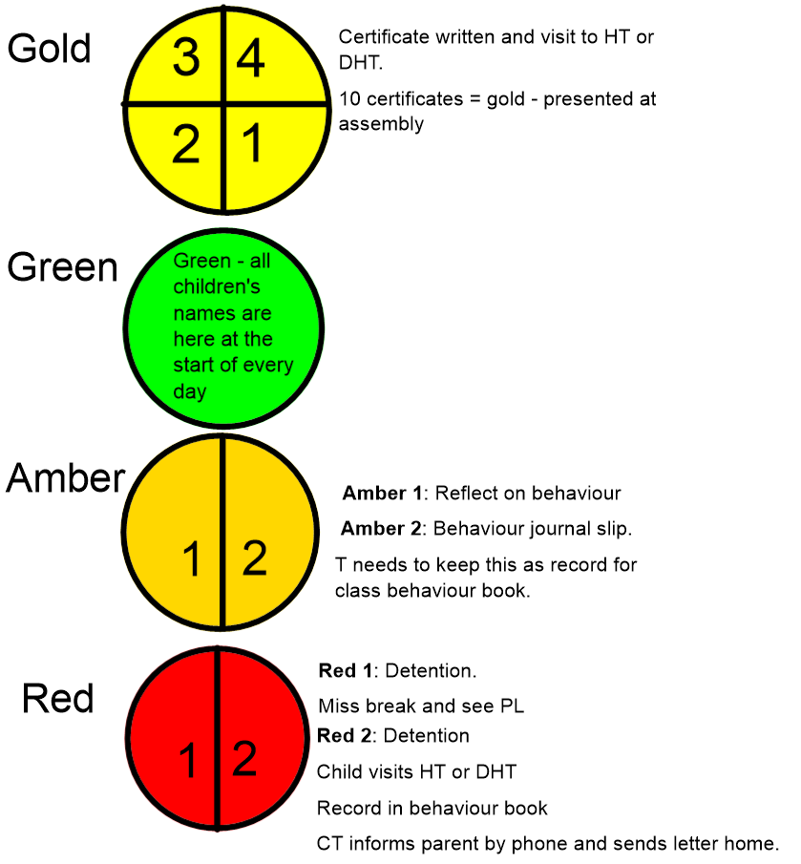

**Rewards**

**Positive behaviours are rewarded.**

* Children are praised orally and awarded a ‘gold’ point on the chart in their classroom for demonstrating appropriate behaviour, as outlined in the Pupil Behaviour Expectations (Pt 6). All staff can reward ‘gold’ points to any children around school, as appropriate.
* When a child receives 4 ‘Gold’ points within a day, they are issued with an ‘Excellent Behaviour’ slip to take to the Headteacher and take home. (see appendix 1)
* When a child receives 10 certificates, they receive a gold certificate, which is presented in assembly. When they receive 40 certificates, they receive a Star certificate in assembly.
* Other reward systems, in addition only to the whole school system, may be used in classes.
* Each week, every class teacher awards a ‘Merit’ to a pupil who has shown excellent behaviour. Their name is announced in assembly and published in the weekly newsletter. Within the school year, it is expected that every child will receive a ‘Merit’.
* A special reward is presented at the end of the year to children who have overcome difficulties and certificates are given in year 6 to recognise their contributions to the school.

**Consequences**

The school uses the traffic light system to make consequences clear for all. If a child chooses to behave in an unacceptable way (as defined in part 2 – Misbehaviour) the following will happen:

* Their name is to ‘Amber 1’ on the behaviour chart. They are asked to reflect on their behaviour. This is intended to be a quick consequence and their name can return to ‘Green’ after correction of behaviour.
* If misbehaviour continues, the child’s name is moved to ‘Amber 2’. At this point, the child is asked to complete a ‘Behaviour Journal’ slip (see appendix 2). The CT keeps this as a record and it is logged on CPOMS. If behaviour is corrected after this consequence, the child’s name can return to ‘Green’.
* If misbehaviour continues, the child’s name is moved to ‘Red 1’. The child now receives a ‘Detention’, misses a break and visits their phase leader. The ‘Behaviour Journal’ slip is taken to the phase leader to scaffold a discussion with the child over the behaviour choices they have made.
* In addition to this, children may also receive a verbal reprimand or be asked to go to another classroom.
* Children may be asked to complete work at home, break or lunchtime if learning time has been missed.
* Serious Misbehaviours (as defined in section 2) are treated as an immediate ‘Red 2’ and children will visit the HT or DHT immediately. The child will be required to
  + Explain why their chosen behaviour is unacceptable
  + Make amends for their behaviour (Eg, apologise or act to resolve the consequences of their behaviour)
  + To attend a series of detentions, depending on the severity of their chosen behaviour.
  + A member of staff will inform parents of the serious misbehaviour and consequences.
  + A letter will be sent home to parents, asking for their support in helping their child to learn from their mistake.
* Please note when class or homework is not completed to an acceptable standard, children will be asked to stay in during a break to edit or complete the task.

**Further Consequences**

* **Internal Exclusion**

Occasionally, repeated **misbehaviours** (section 2) or **serious misbehaviour** (section 2) will warrant a further consequence to those stated above. In this instance, an internal exclusion might be considered. Parents will be informed if their child has been internally excluded and will be requested to attend a meeting. This will be to discuss the reintegration programme including playtimes and the allocation of a mentor. Targets will be agreed at the meeting and a review date set

An internal exclusion is:

* An internal process within the school
* Used when the objective is to remove the pupil from class, not from the school site, for disciplinary reasons
* Not a legal exclusion, so exclusions legislation and government guidance on exclusion from school do not apply

At St Stephens, we place the child in a separate room, with an accompanying adult. They will be set work to complete by their class teacher. They will be taken for ‘breaks’ outside of normal break times to ensure complete isolation from the other children for the day.

* **Exclusion**

In extreme circumstances, exclusion is an option, but this would only occur after full consultation between the child’s parents, the Headteacher and the governors. School will seek advice from the local authority to ensure the child is being treated fairly.

**Pupil Support for SEND children**

The school recognises its legal duty under the Equality Act 2010 to prevent pupils with a protected characteristic from being at a disadvantage. Consequently, our approach to challenging behaviour may be differentiated to cater to the needs of the pupil.

Our SENCO will evaluate a pupil who exhibits challenging behaviour to determine whether they have any underlying needs that are not currently being met.

Where necessary, support and advice will also be sought from specialist teachers, educational psychologist, medical practitioners to identify or support specific needs.

Individual Behaviour Plans (IBDs) may apply to those children whose needs determine it. This is planned with class teacher, SENCO and parents.

**Lunchtime Behaviour**

All staff follow the behaviour system, as outlined in section 7. Extra stickers may be given outside to support positive behaviour management. Any misbehaviour is reported to the class teacher as the class are collected at the end of lunchtime. Class teachers need to be available 5 minutes before the bell rings to allow for this. Serious Misbehaviour, as listed in section 3 is reported to PL, DHT or HT immediately.

Lunchtime staff are made aware of specific circumstances (SEND or other circumstances) which may affect a pupil’s behaviour adversely during lunchtime break.

**Off-Site behaviour**

Consequences may be given when a pupil has misbehaved off-site when representing the school, such as on a school trip. This is recorded in the class behaviour book on return to school and appropriate consequences given.

Both parents and children take responsibility for behaviour and children sign a contract prior to the school journeys in Years 4 and 6. Ultimately, if the contract is broken the parent will be asked to collect their child from the venue.

**CPOMS**

. This is used to:

* Record any misbehaviours within class.
* Record any special arrangements for handing over to visiting staff.
* Keep a pack of Excellent Behaviour Slips, Behaviour Journals and letters home to parents.
* Keep a record of Excellent Behaviour Slips given.
* **Positive Handling**

**Please refer to the Positive Handling Policy.**

**Pupil transition**

To ensure a smooth transition to the next year, pupils have transition sessions with their new teacher(s). To ensure behaviour is continually monitored and the right support is in place, information related to pupil behaviour issues may be transferred to relevant staff at the start of the term or year. Information on behaviour issues may also be shared with the new settings for those pupils transferring to other schools.

**Training**

All staff are provided with training on managing behaviour as part of their induction process.

Behaviour management will also form part of continuing professional development (CPD).

# 11. Monitoring arrangements

This behaviour policy will be reviewed by the Headteacher and full governing body every three years. At each review, the policy will be approved by the Headteacher.

**12. Links with other policies**

This behaviour policy is linked to the following policies:

* Anti-bullying policy
* Safeguarding policy
* Equalities and Inclusion Policy
* Positive Handling Policy
* Keeping Children Safe in Education, DfE, 2022
* Working Together to Safeguard Children, DfE, 2018.

Appendix 1

|  |  |
| --- | --- |
| ststschool_colour | Excellent Behaviour Child’s Name: Class:  Is coming to see Mrs Bachour or Mrs Morrison because they have earned four gold awards today. Well done!  Teacher’s signature: Date: |

|  |  |
| --- | --- |
| ststschool_colour | Excellent Behaviour Child’s Name: Class:  Is coming to see Mrs Bachour or Mrs Morrison because they have earned four gold awards today. Well done!  Teacher’s signature: Date: |

|  |  |
| --- | --- |
| ststschool_colour | Excellent Behaviour Child’s Name: Class:  Is coming to see Mrs Bachour or Mrs Morrison because they have earned four gold awards today. Well done!  Teacher’s signature: Date: |

**Appendix 2**

|  |  |
| --- | --- |
| **Pupil Expectations**  Build each other up in love and learning  Behave in an orderly and self-controlled way  Be respectful to all members of our school community  Use words and actions that always build each other up in love and learning  In class, make it possible for all pupils to learn  Move quietly around the school  Always try your best and be attentive during learning time  Treat the school buildings and school property with respect  Wear the correct uniform at all times  Accept sanctions when given | ststschool_colour  **Behaviour Journal**  Which expectation did I not meet?  What problem did this behaviour cause?    Who did this behaviour most effect?  What should I have done instead?    Signed Date: |

Appendix 3

**The Secure Base Model - Attachment Awareness**

* • The Secure Base Model (Schofield and Beek, 2014) is a resilience-based model that provides a positive framework for therapeutic caregiving that focuses on the interactions between caregivers and pupils on a daily basis.
* • Research (Beek and Schofield 2004 & 2005) has demonstrated that, over time,

positive caregiving across the five dimensions provides a secure base from which the child can explore, learn and develop in a positive direction.

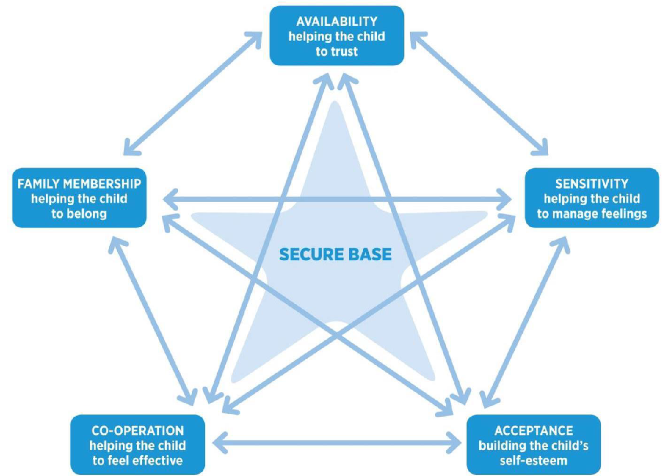

**Top Tips for implementing an Attachment Aware Approach**

❖ **Recognise behaviour as a form of communication**

Consider what might be underpinning a PUPIL’s behaviour. Don’t immediately seek within-child explanations - e.g. labels such as ADHD, ASC. Consider the PUPIL holistically/ in context. Their behaviour might be a very normal response to adverse life experiences.

❖ Promote a positive approach

Spot PUPIL behaving well/ doing the right thing. Offer specific and descriptive praise (or for those PUPIL who find it difficult to accept praise, offer discrete non-verbal feedback). Avoid global statements such as “good boy”.

❖ Differentiate expectations

- *How long should you expect a PUPIL who is hypervigilant to sit still during carpet time or assembly?*

- *What might be realistic expectations (in terms of approach to a task) for a pupil who is terrified of failure?*

- *Remember that work-avoidant behaviour can be linked to a fear of taking risks/feelings of vulnerability – even the risk of asking for help.*

- *Model and explicitly teach what is needed for ‘readiness to learn’, including promoting a growth mindset approach.*

- Set up the expectations accordingly, so that pupils aren’t set up to fail.

❖ Differentiate response

Some pupil perceive/experience public verbal reminders/prompts around expected behaviour very shaming. Consider non-verbal cues/gestures (agreed with the pupil, which can also powerfully remind them that you are holding them in mind). Always ensure that any disapproval expressed is of the behaviour and not the person (i.e. maintain a sense of unconditional positive regard).

❖ Relationships first!

➢ ‘Engage, don’t Enrage’

➢ ‘Connection before Correction’

➢ ‘The 3 Rs: Regulate, Relate, Reason’

Remember empathy comes before limit-setting/problem-solving around the behaviour. Use emotion coaching and attachment aware scripts – e.g. “I’m wondering if (you are shouting out “this is boring!” because) you feel scared about getting the answer wrong? I know what that feels like, it can be really scary to have a go at something, in case you might fail”.

❖ A whole school approach

All members of staff are responsible for supporting the behaviour of pupils across the school. **Attachment/ building relationships is everybody’s business!** The HT and SLT must lead the whole school attachment aware ethos to promote a consistent approach that is embedded across the school, through policy development, displays, choice of language, non-verbal behaviours, and communication with parents/carers, as well as those outside of the school community. One or two ‘key adults’ working to support a pupil using attachment aware approaches is not enough. You need the whole school community to be signed up to an attachment aware approach.

❖ **Use agreed tools for recording, monitoring and sharing planned strategies/ support/ progress around behaviour so that they can be consistently implemented.**

Examples: Personal Education Plans (PEPs) for Children in Care and Previously in Care; the Secure Base Model Checklists, Action and Progress Plans; Pastoral Support Plans (PSPs); Individual Education Plans (IEPs); Provision Maps; Pupil Passports. These should highlight strengths and areas of resilience - not just withinchild but also family/community factors. Include key triggers to avoid escalating situations (e.g. using a loud voice/ threatening body language/ publicly admonishing/confronting). Pupil and their parents/carers need to be involved and central to this

process. Consider who else might need to be involved in support – e.g. other key adults or agencies such as CAMHS or Social Care?

❖ Small actions can make a big difference!

Even smiling at/greeting a pupil on their way into school can really add to their sense of belonging/ feeling liked, respected and valued.

❖ Don’t expect immediate results or returns!

A pupil might be very dismissive of you behaving in a kind/empathic manner towards them, but this doesn’t mean that your actions weren’t important, or valued! It may just mean they are not in a good place to be able to receive kindness and/or that they need lots more experiences of this positive approach/kind behaviour to even begin to internalise a positive sense of self.

❖ **Expect sabotage from some pupils and name it, where appropriate**

Dan Siegel’s ***‘Name it to tame it’***. For example, “Amy, I am wondering if you trashed the room because it feels like too much pressure on you to keep showing such good behaviour all morning, and maybe you are scared of disappointing me or yourself?”

❖ Recognise that what you feel is a likely indication of how the PUPIL feels

If you feel helpless/stuck/frustrated/angry, this is often an important indication of how the pupil is feeling inside and what they are projecting out.

❖ Be cautious around suggestions of a ‘fresh start’

Often people start to look for fresh starts such as another school for a pupil when they feel stuck. Don’t assume anyone else will be able to manage the behaviour any better/ feel less stuck! The problem just becomes someone else’s to deal with! Always consider whether this is really best for the pupil. Often pupils who unconsciously push others away through their behaviour are the ones who have experienced the most rejection and are most successful at being repeatedly rejected/excluded.